ESCC’s Environment Strategy; At pace & at scale’ (2020)
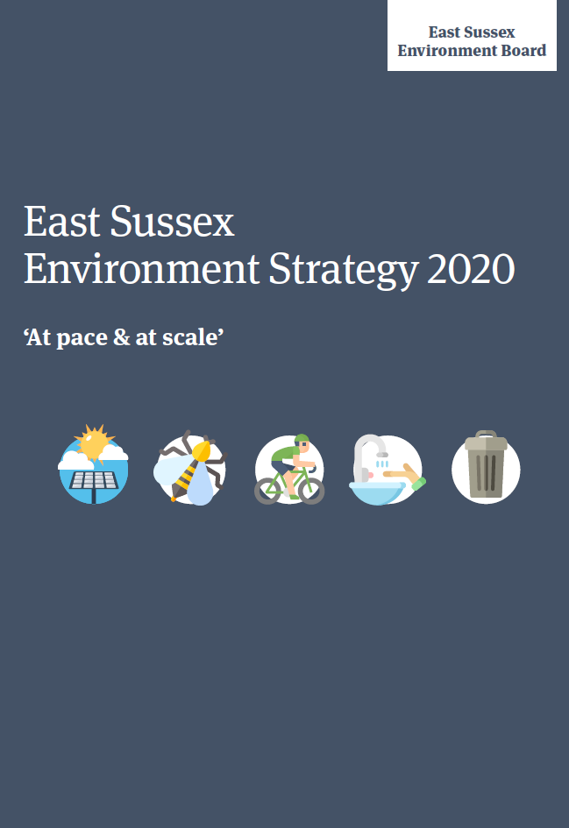
The ESCC Environment Strategy was published in two parts in 2020, the Strategy (16pp) and the Appendix (38pp) dated March 2020 and June 2020 respectively. It replaces the first Environment Strategy for East Sussex adopted in 2011. A lot of rhetoric, national dilemmas, and UK concerns are repeated throughout this document. Turning to East Sussex, it states that 470 species that are globally threatened in the county, or in rapid decline. The Strategy is updated to be in line with the 25 year Environment Plan (2018) and Parliament’s declaration of Climate Emergency in 2019.
The Strategy’s vision is ‘protect and enhance our natural and built environment for current and future generations and tackle and adapt to climate change.’ That is a familiar mantra that goes back decades and is invested in UK law. ‘conserve and enhance’. The Strategy is disappointing in what it does not cover. There are no references to nature conservation or soil conservation, SSSIs, BAPs, Ancient Woodland, Wood-pasture, or surprisingly nothing major on biodiversity. It acknowledges the impact on woodlands in East Sussex (which has more than most counties), especially the impact on associated woodland habitats ‘the loss of valued areas for recreation.’
Natural Capital is mentioned, and is comprehensively dealt with in the Appendix; whilst everyone is nervously awaiting the result of the Environment Bill in its final deliberation on net gain in which way to jump. Nationally, it is interesting to note that OFWAT are aiming to ‘protect and improve at least 6,000km of waterways, and protect and improve 1,800ha of protected nature conservation sites by 2025. One hopes this will trickle down to East Sussex. This will clearly be a rolling strategy for East Sussex, but the document as presented, does not have a functioning feedback email address, and the Team Manager is aware of the various typos and states that further information on nature conservation is to be found in the Sussex Local Nature Partnership document ‘Natural Capital Investment Strategy for Sussex 2019-2024.’ At present, it is a disappointing document.

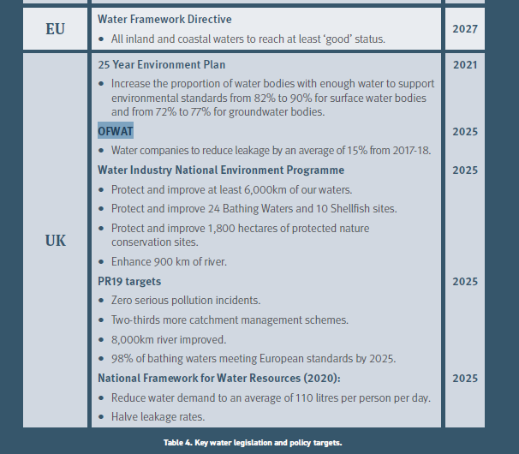

Sussex Local Nature Partnership 2019. Natural Capital Investment Strategy for Sussex, 2019-2024.
Sussex Local Nature Partnership 2019. 83pp. http://sussexlnp.org.uk/wp-content/uploads/2019/12/Natural-Capital-Investment-Strategy_ADOPTED_Final_Dec2019.pdf

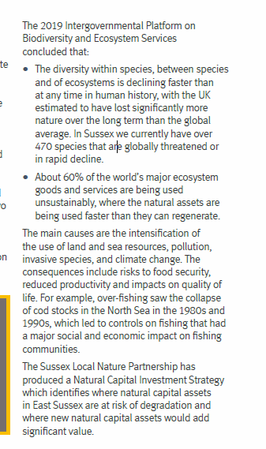
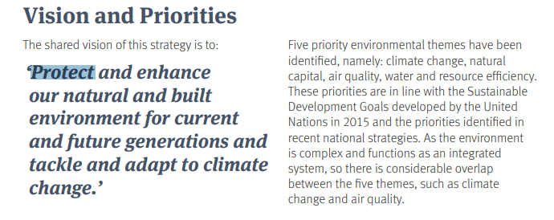

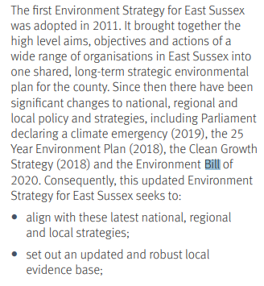
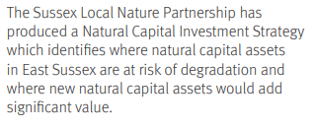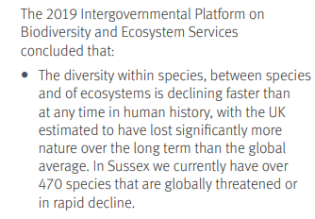

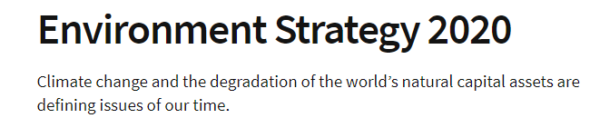
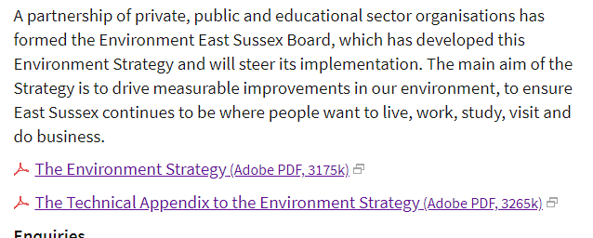
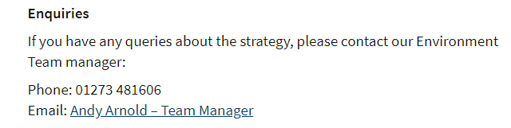
Sussex Local Nature Partnership Oct 2019http://sussexlnp.org.uk/wp-content/uploads/2019/12/Natural-Capital-Investment-Strategy_ADOPTED_Final_Dec2019.pdf

Re loss of valued areas for recreation
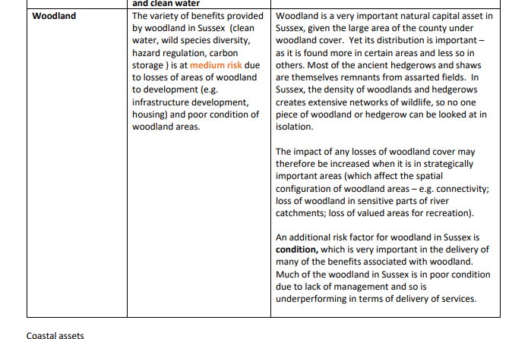

East Sussex County Council, 2020. Is in two parts i) ‘The Environment Strategy’, dated March 2020 (16pp) and ‘The Technical Appendix to the Environment Strategy’, dated June 2020 (38pp). https://www.eastsussex.gov.uk/media/15587/east-sussex-environment-strategy-2020.pdf https://www.eastsussex.gov.uk/media/15589/east-sussex-environment-strategy-2020-technical-appendix.pdf (accessed 01 December 2020).

